SUSTAINABILITY REPORT 2024-2025-2026

The hotel is committed to provide high quality hospitality services and try to exceed customer expectations by creating a friendly and hospitable atmosphere for their customers.
We continually seek to improve our services whilst minimize our negative environmental impact. Thus, achieving a safe and sustainable environment, contributing to the local community and complying with Health & Safety legislation are key issues in our policy.
Our principles include:
• Conserving our natural resources through the implementation of routine actions and by sustainable management
• Conserving energy and water
• Reducing, reusing & recycling waste
• Complying with relevant environmental legislation and regulations
• Supporting the local community by employing local people wherever possible and purchasing products and services from local suppliers
• Raising awareness to our staff on conservation energy issues
• Complying with health and safety legislative requirements
• Promoting, wherever possible, renewable and sustainable energy sources
• Setting energy and quality targets and regularly monitoring and evaluating our energy and quality performance
• Reviewing objectives & targets with the aim to continually improve on minimizing our environmental impact
During the summer period of 2024 our hotel has employed 330 people. Out of these people, 153 are men (46,36%) and 177 are women (53,64 %). Furthermore, we support multinational and multicultural working environment, due to that our employees come from various backgrounds and ethnicities, such as Albania, Romania 150(45,45 %) people come from other ethnicities, while the rest 180 (54,55%) are from Rhodes and Greece.
During the summer period of 2025 our hotel has employed 318 people. Out of these people, 154 are men (48,42%) and 164 are women (51,57 %). Furthermore, we support multinational and multicultural working environment, due to that our employees come from various backgrounds and ethnicities, such as Albania, Romania 143(44,96%) people come from other ethnicities, while the rest 175 (55,03%) are from Rhodes and Greece.

During the summer period of 2026 our hotel has employed 289 people. Out of these people, 145 are men (50.17%) and 144 are women (49.82 %). Furthermore, we support multinational and multicultural working environment, due to that our employees come from various backgrounds and ethnicities, such as Albania, Romania, filippines 151(52.24%) people come from other ethnicities, while the rest 138 (47.75%) are from Rhodes and Greece.
Correspondingly our top management positions are comprised of 5 women 9 men.
- Our target for 2026 is to keep a ratio of men to women 50% for each
Annual Comparison Staff Allocation
- | 2024 | 2025 | 2026 | 2027
Men | 153 | 154 | 145 | TBD next assessment
Women | 177 | 164 | 144 | TBD next assessment
Local | 180 | 175 | 138 | TBD next assessment
Non-local | 150 | 143 | 151 | TBD next assessment
- Our target for 2026 is to have at least 50% of our employees as locals.

Αs shown In 2026, the target of maintaining an equal gender ratio was successfully achieved. The staff allocation consisted of 145 men (50.2%) and 144 women (49.8%), demonstrating an almost perfectly balanced distribution between male and female employees. Compared with previous years, the results show a clear improvement towards gender balance.
Assessment of 2026 Targets
2026 Target | 2026 Result / Action Taken | Status
Maintain a 50% men – 50% women ratio | Men: 50.17 % / Women: 49.82 %. | ✅ Achieved
Have at least 50% local employees | Local staff: 47.75% | Nearly achieved

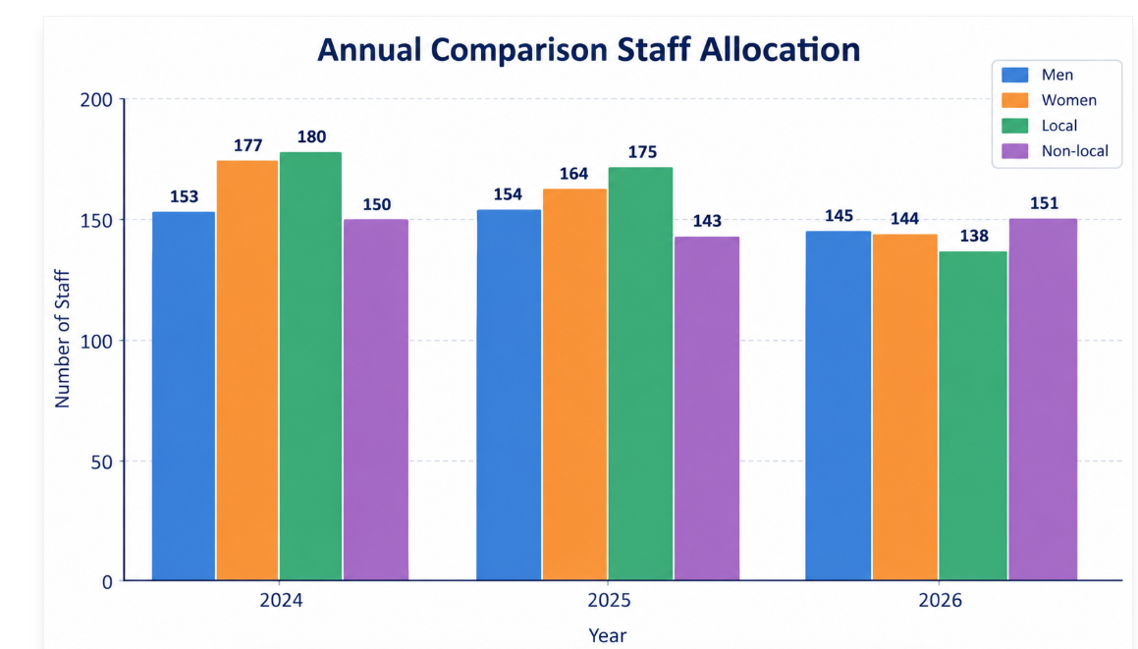
COMMUNITY - PROCUREMENT OF GOODS
We believe that responsible sourcing of goods is essential to reducing our environmental footprint and supporting local communities. Therefore, we prioritize procuring goods from suppliers who adhere to ethical and eco-friendly standards. Our procurement team diligently evaluates suppliers based on criteria such as fair labor practices, sustainable production methods, and minimal environmental impact.
By choosing suppliers who share our values, we aim to not only provide our guests with high-quality products but also contribute to a more sustainable future for our planet. From locally sourced organic produce to eco-friendly cleaning products, every purchasing decision AKTI IMPERIAL reflects our dedication to sustainability."
We promote local culture by providing our guests with information on local sights, cultural and natural heritage guest experience leaflet upon their arrival at hotel in each respective room.
- Our target for 2026 is to have at least 75% of our primary suppliers as local companies
- Our target for 2026 is to increase our procurement of products with sustainability label
- Our target for 2026 is to organize at least 1 an activity with the participation of staff, customers and locals. For example tree-planting activity.
Annual Comparison Suppliers
- | 2024 | 2025 | 2026 | 2027
Locals | 79 | 84 | 89 | TBD next assessment
Non-Local | 32 | 20 | 25 | TBD next assessment

AKTI IMPERIAL on 2026 purchases its goods and services from both local and non-local suppliers. Our primary suppliers are 114 for 2026 and out of them, 89 (78,07%) are locals whilst the rest 25 (21.9%) are non-locals.
The Hotel participated in the celebration of the Artamitis Monastery twice in 2026 with the donation of a buffet and assistance with preparation and execution tasks from hotel staff.
As shown in the annual comparison, the number of local suppliers has steadily increased from 79 in 2024 to 84 in 2025 and 89 in 2026, while the percentage of local primary suppliers reached 78.07% in 2026, exceeding the target of 75%. At the same time, the hotel continued to strengthen the procurement of products with sustainability labels and increased its involvement in local community activities. Overall, the results demonstrate a positive trend towards more responsible and sustainable procurement practices and stronger support for the local community.

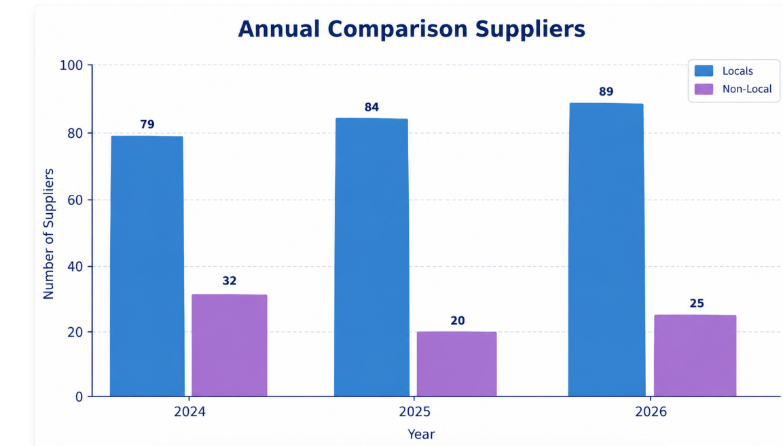
2026 Target | 2026 Result / Action Taken | Status
At least 75% of primary suppliers to be local companies. | 89 out of 114 primary suppliers are local companies, representing 78.07%. | ✅ Achieved
Increase procurement of products with sustainability labels. | Procurement of products with sustainability labels was increased, supporting the hotel’s commitment to responsible and sustainable sourcing. | ✅ Achieved
Organize at least one activity with the participation of staff, customers and local community in Agios Fokas. | The hotel participated in the celebration of Artamitis Monastery twice in 2026, with a buffet donation and the participation of hotel staff in preparation and execution activities. | ✅ Achieved

Our Targets for 2027 :
Local Suppliers | Maintain at least 80% of primary suppliers as local companies.
Sustainable Procurement | Increase the procurement of products with recognized sustainability labels, including MSC-certified seafood products.
Community Engagement | Organize at least 2 community activities involving staff, customers, and local residents in the Agios Fokas and surrounding areas.
Environmental Awareness | Expand staff participation in environmental initiatives such as beach cleanups, tree planting, or recycling campaigns.
Local Community Support | Continue supporting local cultural and religious events through donations, partnerships, or sponsorship activities.

WASTE MANAGEMENT
At AKTI IMPERIAL, we understand the importance of responsible waste management in minimizing our environmental impact. We have implemented comprehensive waste management practices aimed at reducing, reusing, and recycling waste throughout our operations. Our staff is trained to segregate waste effectively, ensuring that recyclable materials are separated from general waste. Additionally, we actively seek partnerships with waste management companies that prioritize environmentally friendly disposal methods, such as waste-to-energy technologies. Through these efforts, we strive to minimize the amount of waste sent to landfills and reduce our carbon footprint. Furthermore, we continuously evaluate our waste management strategies to identify areas for improvement and innovation. By adopting sustainable waste management practices, AKTI IMPERIAL is committed to preserving the environment for future generations while providing our guests with an eco-conscious hospitality experience.
Our primary waste recycling is glass, paper, plastic, aluminum, used cooking oil, batteries and cartons, light bulbs,toner and inks.
In order to support the waste recycling of the above mentioned we have spread throughout the hotel recycling bins for plastic, paper which then we gather and move them to the corresponding waste bins provided by the municipality to collect.
We have 3 big and 1 small recycling bin each for glass, waste press for carton in our parking area where authorized companies take the wastes and replace the bins
For batteries there are 1 cylindrical bins positioned outdoor of mini market where at the end of the season or in the middle of the season if its necessary they are retrieved by authorized companies.
For used oils, we have 6 bins in the departments where they are collected by an authorized company, reco oil, every month.
We have a collaboration with recycling S.A. where we use special bins for the collection of household appliances, inks and toners, as well as lamps, which come once or twice into the collection for recycling.
For urban wastes there are bins spread throughout the premises where at the end of the day they are retrieved and placed in specific ones provided by the municipality and stored in a storage area for them to be taken by the local authorities
- Our target for 2026 is to reduce the food waste produced by 2%
- Our target for 2026 is to promote recycling and increase recycled waste by 5%
 |  | Annual Comparison Waste
- | 2024 |  | 2025 | 2026* | 2027
Food Waste | 77294 |  | 75817 | 73166 | TBD next assessment
Plastic and paper | 27110 |  | 11960 | 7920 | TBD next assessment
*2026 data until 31 August 2026, based on 243,046 guest nights.
As shown in the annual comparison, the hotel has achieved a positive trend in waste management between 2024 and 2026. Food waste decreased from 77,294 kg in 2024 to 75,817 kg in 2025 and further to 73,166 kg in 2026, resulting in a 5.34% reduction compared with 2025 and exceeding the 2% reduction target. Similarly, plastic and paper waste decreased significantly from 27,110 kg in 2024 to 11,960 kg in 2025 and 7,920 kg in 2026. Overall, these results demonstrate continuous improvement in waste prevention and responsible waste management, while recycling practices will continue to be strengthened.
2026 Target | 2026 Result | Status
Reduce food waste by 2%. | Food waste decreased from 75,817 kg in 2025 to 73,166 kg in 2026, representing a 5.34% reduction. | ✅ Achieved
Promote recycling and increase recycled waste by 5%. | Plastic and paper waste decreased from 11,960 kg in 2025 to 7,920 kg in 2026, showing a significant reduction of waste generation and continued improvement in waste management. | 🟡 Partially achieved / Ongoing

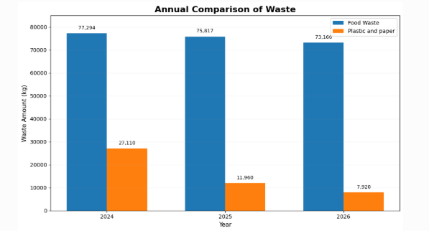

Our Targets for Waste Management for 2027
Reduce food waste | Achieve an additional reduction of at least 2–3% in food waste compared to 2026 levels through improved stock control, portion management, and waste monitoring.
Reduce plastic and paper waste | Continue minimizing plastic and paper consumption by increasing recycling practices and promoting reusable and digital alternatives.
Improve recycling performance | Increase waste separation and recycling rates across all operational areas.
Employee awareness and training | Conduct awareness campaigns and staff training on waste reduction, recycling, and sustainable practices.
Promote sustainable operations | Encourage suppliers and departments to adopt environmentally friendly packaging and reduced material usage.
Strengthen waste monitoring | Improve monthly tracking and reporting of waste streams to identify reduction opportunities and ensure continuous improvement.

CHEMICALS
In year 2024 AKTI IMPERIAL used totally 35377 kg of Environmentally Hazardous Substances (which include Cleaning or sanitizing chemicals for housekeeping / food and beverage departments chemicals, Pool Chemicals and ground/garden chemicals).
In year 2025 AKTI IMPERIAL used totally 31371 kg of Environmentally Hazardous Substances (which include Cleaning or sanitizing chemicals for housekeeping / food and beverage departments chemicals, Pool Chemicals and ground/garden chemicals).
In year 2026AKTI IMPERIAL used totally 24675,5 kg of Environmentally Hazardous Substances (which include Cleaning or sanitizing chemicals for housekeeping / food and beverage departments chemicals, Pool Chemicals and ground/garden chemicals).
In order to ensure that the correct amount of chemical is used for the daily cleaning activities chemical dispenser are installed in the housekeeping and kitchen areas to ensure the correct dosage of laundry or cleaning chemicals
Cleaning Program with depictions of the correct chemicals are placed in various areas where chemicals are frequently used i.e kitchen, housekeeping

- Our target for 2026 is to reduce chemical consumption by 2% and to research for environmentally friendly Chemicals where possible
- Our target for 2026 is to conduct training by an external contractor to educate the employees on the correct, efficient and safe use of those chemicals
Annual Comparison Hazardous Substances
- | 2024 | 2025 | 2026* | 2027
Pool chemicals | 8358 | 7656 | 4538 | TBD next assessment
Chemicals for Food and beverage | 15782 | 15204 | 12773,50 | TBD next assessment
Housekeeping chemicals | 3392 | 3217 | 1503 | TBD next assessment
Laundry Chemicals | 6039 | 5300 | 5861 | TBD next assessment
Total | 35371 | 31377 | 24675,5

*2026 data until 31 August 2026, based on 243,046 guest nights.
As shown by the results, the 2026 target of reducing chemical consumption by 2% was successfully achieved and significantly exceeded, with an overall reduction of 21.36% compared with 2025. The results demonstrate a substantial improvement in the hotel's management and monitoring of hazardous substances. The continued investigation of environmentally friendly alternatives, together with employee training on the correct, efficient and safe use of chemicals, will remain an important focus for the following year.
2026 Targets | Result / Status | 2026 Targets
Reduce chemical consumption by 2% compared with 2025 | Achieved – 21.36% reduction | Reduce chemical consumption by 2% compared with 2025
Research and use environmentally friendly chemicals where possible | Achieved / Ongoing | Research and use environmentally friendly chemicals where possible
Conduct external contractor training on the correct, efficient and safe use of chemicals | Achieved | Conduct external contractor training on the correct, efficient and safe use of chemicals

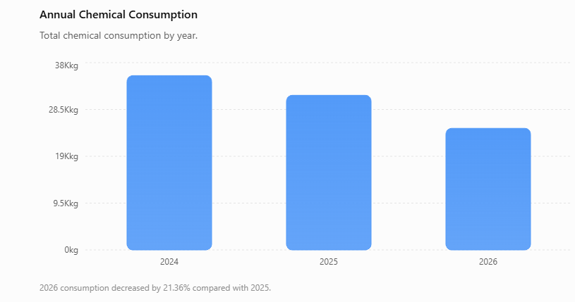
Our Targets for Hazardous Substances for 2027

- Further reduce total chemical consumption | Achieve an additional reduction of at least 3 % in total hazardous substances consumption compared to 2026 levels.

- Increase use of environmentally friendly chemicals | Continue researching and replacing conventional chemicals with environmentally friendly and biodegradable alternatives where operationally possible.

- Improve chemical efficiency | Optimize chemical dosing and handling procedures to minimize waste and unnecessary consumption.

- Employee training and awareness | Conduct refresher training sessions for employees on the safe, efficient, and economical use of chemicals.

- Strengthen monitoring and reporting | Improve tracking and monthly monitoring of hazardous substances to identify reduction opportunities and ensure compliance with environmental standards.

- Enhance storage and safety practices | Maintain safe storage, handling, and disposal procedures to reduce environmental and operational risks.

WATER
In year 2024 AKTI IMPERIAL had a total water consumption of 98.888 (m³) for the entire hotel season and 320.602 guests.
In year 2025 AKTI IMPERIAL had a total water consumption of 95.339 (m³) for the entire hotel season and 333.656 guests.

In year 2026 AKTI IMPERIAL had a total water consumption of 63.473 (m³) for the entire hotel season and 243.046 guests until 31 August.

In order to reduce the water consumption the hotel has Posters on saving water are placed on staff notice boards about environmental management tips.
The watering of our gardens takes between 07:00 and 09:00 am in order to prevent water waste. The watering of the gardens is done automatically by using a timer.
Our aim for 2026 is:
- is to reduce the level of water consumption by 2%
- is to install water usage measurement equipment hotel sections to specify the water consumption for each hotel area/section
Annual Comparison Water Usage
Water consumption | Total m3 | Average m3 per guest night | Total kg CO₂e | Average  kg CO2e per guest night
2024 | 98.888 | 0,31 | 34.000 | 0,106
2025 | 95.339 | 0.29 | 32,770 | 0,100
2026* | 63473 | 0,26 | 21,822 | 0,090
2027 | TBD next assessment

*2026 data until 31 August 2026, based on 243,046 guest nights.
As shown, water consumption decreased from 98,888 m³ in 2024 to 95,339 m³ in 2025, and further to 63,473 m³ in 2026 up to the end of August. The average water consumption per guest night also decreased from 0.31 m³ in 2024 to 0.29 m³ in 2025 and 0.26 m³ in 2026.
Compared with 2025, total water consumption has decreased by approximately 33.41%, while consumption per guest night has decreased by approximately 10.34%. The corresponding CO₂e emissions decreased from 32,770 kg CO₂e in 2025 to approximately 21,822 kg CO₂e in 2026, with emissions per guest night falling from 0.100 to 0.090 kg CO₂e.

2026 Target | 2026 Result | Status
Reduce water consumption by 2% | Consumption per guest night decreased from 0.29 m³ to 0.26 m³ (10.34% reduction) | ✅ Achieved
Install water usage measurement equipment in hotel sections to monitor consumption by area | Measurement equipment installation and monitoring by hotel section | 🟡 Partially achieved / Ongoing

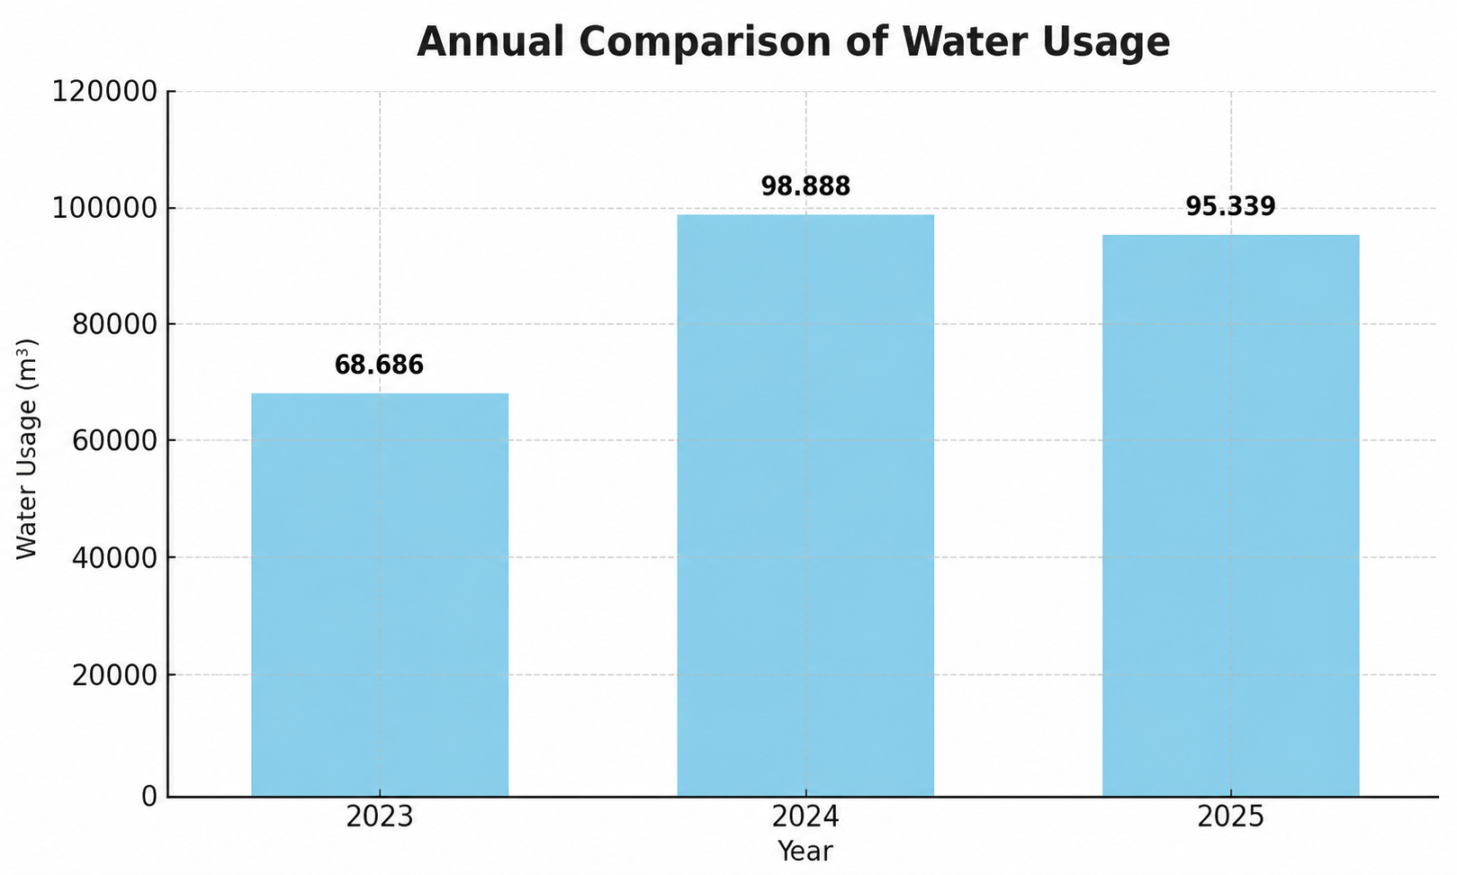

Our targets for 2027 :

Area | 2027 Target | Measurement | Rationale
Total water consumption | -2% vs 2026 | m³ | Continue downward trend and improve efficiency after 2026 reduction
Water per guest night | -3% vs 2026 | m³/guest night | Improve operational efficiency per occupancy
CO₂e from water use | -2% vs 2026 | kg CO₂e | Align emissions reduction with water savings
Sub-metering installation | 100% coverage of key hotel sections | % of areas measured | Enable accurate tracking per department/zone
Data accuracy & monitoring | Monthly reporting per department | Reporting frequency | Improve transparency and early detection of waste
Operational efficiency | Reduce avoidable water loss (leaks/overuse) | qualitative + maintenance logs | Support technical optimisation

ENERGY
In year 2024 AKTI IMPERIAL had a total energy consumption of 5.121.791 kwh for the entire season.
In year 2025 AKTI IMPERIAL had a total energy consumption of 4.817.743
kwh for the entire season.
In year 2026 AKTI IMPERIAL had a total energy consumption of 1.618.994
kwh until 31 August.

In order to reduce energy usage we have implemented systems for magnet to switch off A/C units automatically when guests open the terrace door.
Posters on saving energy are placed on staff notice boards about environmental management tips. Information about save energy is placed in every room television also in puplic televisions.
Heat pumps and solar panels are installed for the heating and distribution of the hot water of the hotel

Our aim for 2026 is:
- is to reduce the level of energy consumption by 2%
Energy consumption | Τotal kWh | Average kWh per guest night | Total kg CO₂e | Average  kg CO2e per night επισκέπτη
2024 | 5.121.791 | 15,98 | 1.192.059 | 3,72
2025 | 4.817.743 | 14,44 | 1,121,000 | 3.36
2026* | 1.618.994 | 6,66 | 376,628 | 1,55
2027 | TBD next assessment
*2026 data until 31 August 2026, based on 243,046 guest nights.
2026 Target | 2026 Result | Status
Reduce energy consumption by 2% | Energy consumption per guest night decreased from 14.44 kWh in 2025 to 6.66 kWh in 2026 (until 31/08/2026), representing a 53.88% reduction | ✅ Achieved

As shown, total energy consumption decreased from 5,121,791 kWh in 2024 to 4,817,743 kWh in 2025. In 2026, consumption reached 1,618,994 kWh up to 31 August.
When adjusted for guest nights, energy consumption decreased from 15.98 kWh per guest night in 2024 to 14.44 kWh in 2025 and 6.66 kWh in 2026. This represents a 53.88% reduction compared with 2025, meaning that the 2026 target of reducing energy consumption by 2% has been achieved based on the available year-to-date data.
The 2026 results indicate a significant improvement in energy efficiency, while continued monitoring until the end of the year will provide the final annual comparison.

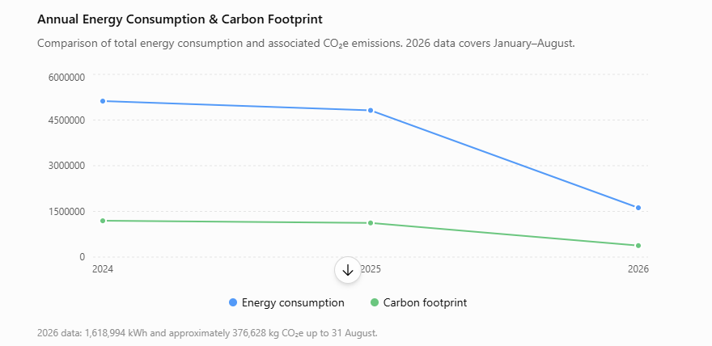
Our targets for Energy for 2026
- Reduce total energy consumption by 3–4% compared to 2025 levels
- Reduce energy intensity to below 13.8 kWh per guest night
- Reduce total CO₂e emissions by approximately 9%
- Reduce carbon intensity to below 3.0 kg CO₂e per guest night
- Improve operational energy efficiency through HVAC and lighting optimization
- Strengthen ESG monitoring through quarterly sustainability reviews
- Increase employee engagement in sustainability initiatives
- Evaluate renewable energy and low-carbon operational opportunities
FUEL CONSUMPTION
Fuel consumption for 2024 is 49.787 lt for the entire season.
Fuel consumption for 2025 is 94.258 lt for the entire season.
Fuel consumption for 2026 is 65.919 lt until 31 August.
Our aim for 2026 is:
- Our target for 2026 is to reduce fuel consumption by 2% this year.
Annual Comparison Fuel Consumption
- | 2024 | 2025 | 2026* | 2027
Fuel (Lt) | 49.787 | 94.258 | 65919 | TBD next assessment

2026 Target | Result | Status
Reduce fuel consumption by 2% | Fuel consumption per guest night decreased from 0.294 L in 2025 to 0.271 L in 2026, representing a reduction of approximately 7.75% | ✅ Achieved

• 2025: 94,258 L ÷ 320,602 guest nights = 0.294 L/guest night
• 2026: 65,919 L ÷ 243,046 guest nights = 0.271 L/guest night
• Reduction: 7.75%
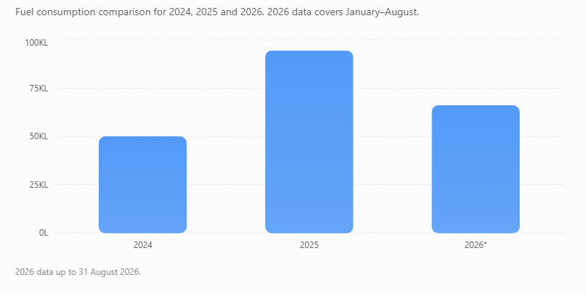
As shown, fuel consumption increased significantly in 2025 compared with 2024. In 2026, total consumption reached 65,919 L up to 31 August. Since 2026 represents only part of the season, the most representative comparison is fuel consumption per guest night. On this basis, consumption decreased by 7.75% compared with 2025, exceeding the 2% reduction target.
Therefore, the 2026 target was achieved based on the available data up to 31 August 2026.
Our targets for 2027 ;
- Reduce total fuel consumption by 2% compared to 2026 levels
- Improve fuel efficiency through optimized boiler operation and preventive maintenance
- Reduce unnecessary fuel use by enhancing heating and cooling management systems
- Monitor fuel consumption monthly to identify operational inefficiencies
- Improve energy management practices during periods of extreme weather conditions
- Evaluate alternative and lower-emission energy solutions where feasible
- Increase operational awareness and staff engagement in fuel-saving practices
MANAGEMENT OF HAZARDOUS SUBSTANCES
At Akti Imperial Deluxe Hotel, hazardous substances are managed through controlled storage, safe handling, staff training, and regular monitoring to minimize risks to employees, guests, the environment, and hotel facilities.
Key measures include:
- Safe Storage: All chemicals are stored in designated, secure and well-ventilated areas, away from food, heat sources and unauthorized access.
- Correct Labelling: All products are kept in their original, clearly labelled containers and accompanied by the appropriate Safety Data Sheets (SDS).
- Controlled Use: Chemicals are used strictly according to manufacturers’ instructions and the required dilution and dosage.
- Personal Protective Equipment (PPE): Employees handling hazardous substances use appropriate protective equipment, such as gloves, protective footwear, goggles or masks where required.
- Staff Training: Employees receive regular information and training on safe handling, storage, dilution, emergency procedures and chemical risks.
- Departmental Control: Chemical consumption is monitored by department, particularly in Housekeeping, Laundry, Food & Beverage and Pool Operations.
- Spill & Emergency Procedures: Procedures are in place for accidental spills, exposure, leaks and other chemical-related incidents.
- Environmental Management: The hotel aims to reduce unnecessary chemical consumption and progressively introduce more environmentally friendly products where suitable.
- Regular Monitoring: Chemical stocks, storage conditions, usage and safety practices are checked regularly to ensure compliance with internal procedures and applicable requirements.
2027 Objective:
Reduce the overall consumption of hazardous substances by 2%, continue staff training, and increase the use of environmentally friendlier chemical products wherever operationally appropriate.
BIODIVERSITY
At Akti Imperial Deluxe Hotel, we are committed to protecting local biodiversity and promoting environmentally responsible practices that support the natural ecosystem of Rhodes.
Key actions include:
- Native Mediterranean Plants: The hotel prioritizes native and drought-resistant species such as oregano, basil, rosemary and mint, which are well adapted to the local climate.
- Reduction of Chemicals: The use of pesticides and unnecessary fertilizers is avoided wherever possible to protect soil, plants, insects and surrounding ecosystems.
- Pollinator Protection: Plants that attract and support bees and butterflies are incorporated into the hotel’s green areas.
- Sea Lily Protection: The hotel supports awareness and protection of the Sea Lily (Pancratium maritimum), a protected Mediterranean coastal plant.
- Guest Awareness: Information and awareness activities are used to encourage guests and staff to respect local flora and fauna.
- Protection of Coastal Areas: Special attention is given to the protection of the surrounding coastal environment and sensitive areas.
- Responsible Landscaping: Irrigation and landscaping practices are adapted to reduce water consumption and minimize environmental impact.
2027 Objective:
Continue protecting local biodiversity through the use of native and drought-resistant plants, reduction of chemical use, protection of pollinators and increased awareness among guests and employees.
General Sustainability Conclusion
The Company remains committed to continuously improving its environmental and sustainability performance through responsible resource management, operational efficiency, and the implementation of ESG-oriented practices across all activities.
During the reporting period, environmental indicators reflected both the increased operational activity and the growing number of guests served. Energy consumption, CO₂e emissions, and fuel consumption were influenced by higher operational demands and less favorable weather conditions, which required increased use of boilers for hot water production as well as heating and cooling needs in order to maintain guest comfort and service quality.
At the same time, the Company continued to implement initiatives focused on energy efficiency, emissions reduction, fuel management, and environmental awareness. Biodiversity protection also remains an important priority through the preservation of native Mediterranean vegetation, the avoidance of harmful chemicals, and the promotion of local flora and sustainable practices.
Looking ahead, the Company aims to further reduce its environmental footprint by improving operational efficiency, strengthening sustainability governance, enhancing employee and guest awareness, and evaluating lower-carbon and environmentally responsible solutions. Through continuous monitoring and measurable sustainability targets, the Company seeks to support long-term environmental resilience while maintaining high operational and hospitality standards.
Hotel Manager
Μichalis Symiakos
15/09/2026

